**STAT 477/STAT 577**

**HW 7**

**Neha Maddali**

1. Sample proportion of cannibalism = 0.2115385

2. Equation for predicted log odds of cannibalism: = B0 + B1xi = 3.09 – 3.07*(size difference)

3. Equation for predicted probability of cannibalism: p = e^(3.09 – 3.07*Size Difference)/(1+e^(3.09-3.07*Size Difference))

4. Interpretation of slope: For every one unit increase in the difference of female and male spider size is associated with an e-3.07 times decrease in the predicted odds of cannibalism.

Interpretation of intercept: When the difference in female and male spider size is 0, the predicted odds of cannibalism is e-3.09

5. Predicted probability of cannibalism for size difference = -0.2mm: 0.02405977

Predicted probability of cannibalism for size difference = 0.4mm: 0.1345539

6. 95% confidence interval for probability of cannibalism for size difference = 0mm: (0.008894204, 0.1877545)

Interpretation: We are 95% confident that the true probability of cannibalism for a size difference of 0 mm falls within 0.0089 and 0.1878. There is a relatively low to moderate probability of cannibalism when the size difference between the female and male spiders is zero.

95% confidence interval for probability of cannibalism for size difference = 0.8mm: (0.1831188, 0.5567838)

Interpretation: We are 95% confident that the true probability of cannibalism for a size difference of 0.8 mm falls within 0.183 and 0.557. The interval suggests a moderate to high probability of cannibalism when there is a size difference of 0.8 mm between female and male spiders.

7. Hypothesis test for slope:

Null Hypothesis: The size difference between the female and male spiders does not have a significant effect on the probability of cannibalism.

Alternative Hypothesis: The size difference between the female and male spiders has a significant effect on the probability of cannibalism.

Wald Test Statistic: 3.057

Wald p-value: 0.002237

Wald Conclusion: There is sufficient evidence to conclude that the size difference between the female and male spiders has a significant effect on the probability of cannibalism

Likelihood Ratio Test Statistic: 18.942

Likelihood Ratio Test p-value: 1.348×10 −5

Likelihood Ratio Test Conclusion: There is sufficient evidence to conclude that the size difference between the female and male spiders has a significant effect on the probability of cannibalism

8. pseudo R^2 = 0.3529793

Comment on value: This value suggests that the model explains a moderate amount of variability in the probability of cannibalism based on the size difference between the female and male spiders. While it's not extremely high, it's also not insignificant. This indicates that the size difference variable, while statistically significant, might not capture all the factors influencing cannibalism behavior in wolf spiders.

9. Hosmer-Lemeshow Test

Null Hypothesis: The logistic regression model fits the data well.

Alternative Hypothesis: The logistic regression model does not fit the data well.

Test Statistic: 3.0035

p-value: <0.3911

Conclusion: There is weak evidence that there is a lack of model fit for the logistic regression with size difference in this population.

10. Confusion Table

Agreement: The agreement between the observed and predicted values in the confusion table is 0.8077. This suggests that the logistic regression model correctly predicts cannibalism outcomes in approximately 80.77% of cases.

Sensitivity: The sensitivity of the mode is 0.2727. This indicates that the model correctly identifies 27.27% of the actual cannibalism events.

Specificity: The specificity of the model is 0.9512. This suggests that the model correctly identifies 95.12% of the instances where cannibalism doesn’t occur.

11. ROC Curve

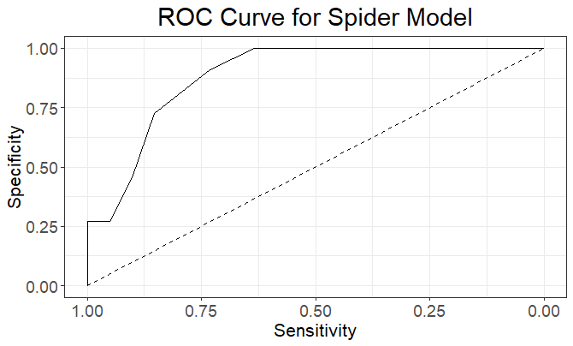

Area Under ROC Curve = 0.8869

Interpretation: The AUC-ROC value indicates that the logistic regression model has good discriminatory power in distinguishing between the classes (cannibalism and non-cannibalism). Specifically, it suggests that the model has a 88.69% chance of correctly ranking a randomly chosen cannibalism instance higher than a randomly chosen non-cannibalism instance.